Application:
Clone the below mentioned repository and deploy the application (Run application in port 3000).
Repo URL : https://github.com/Vennilavanguvi/Trend.git
Docker:
- Dockerize the application by creating Dockerfile+
- Build an application and check output using docker image.

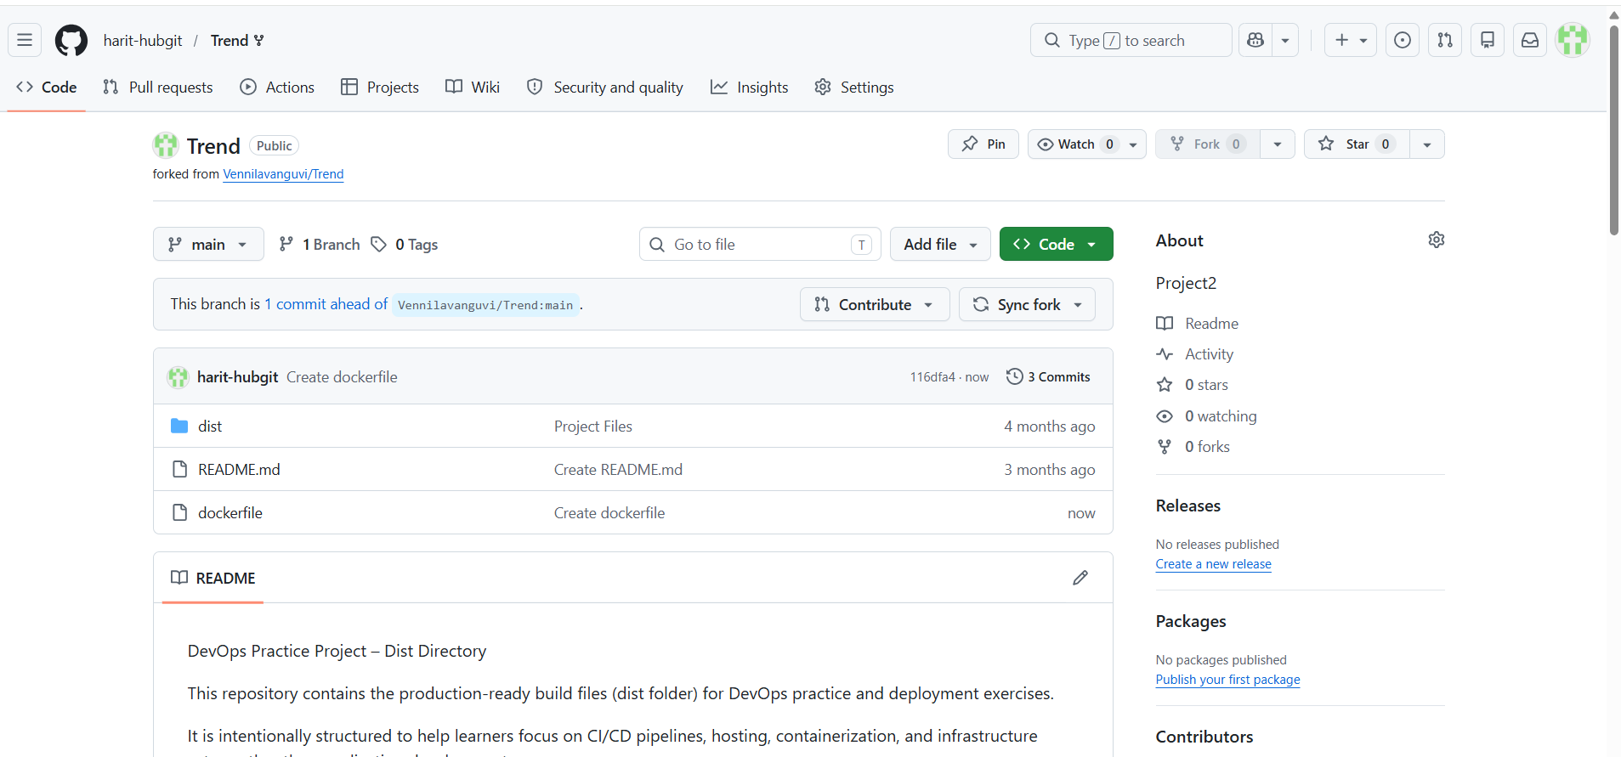

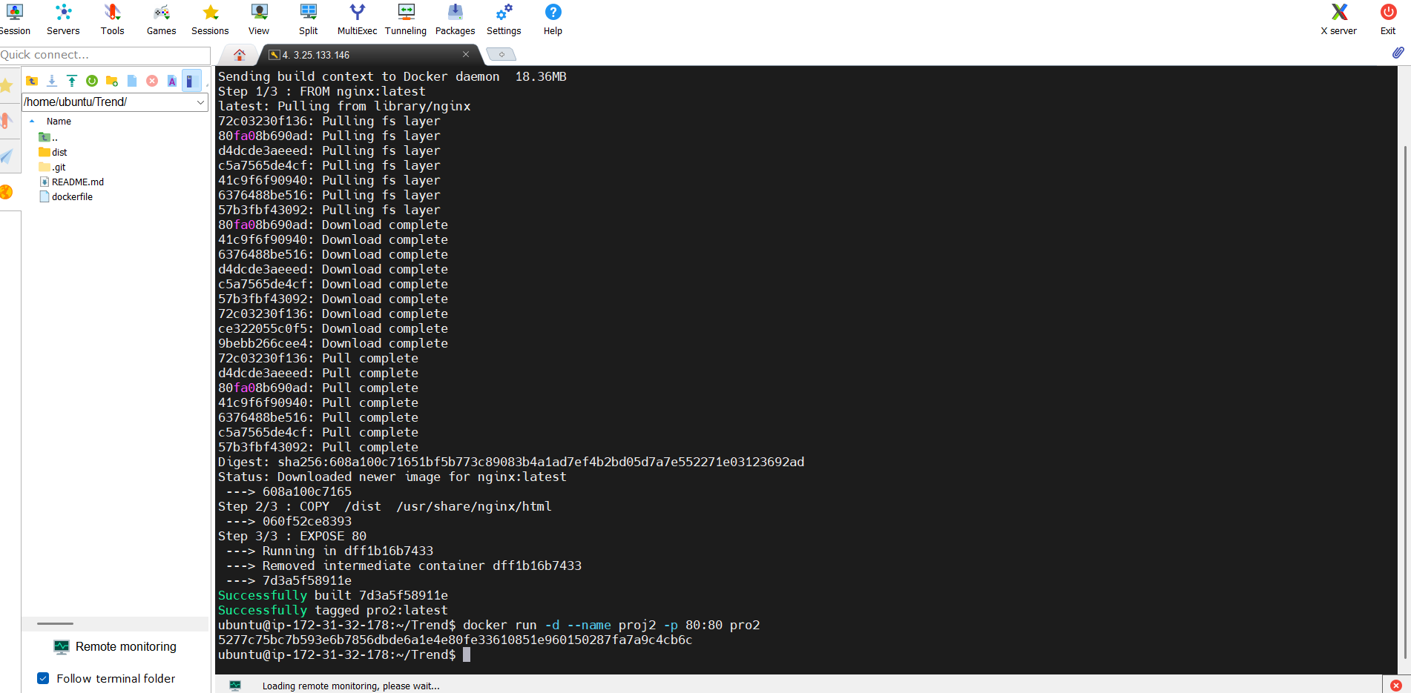

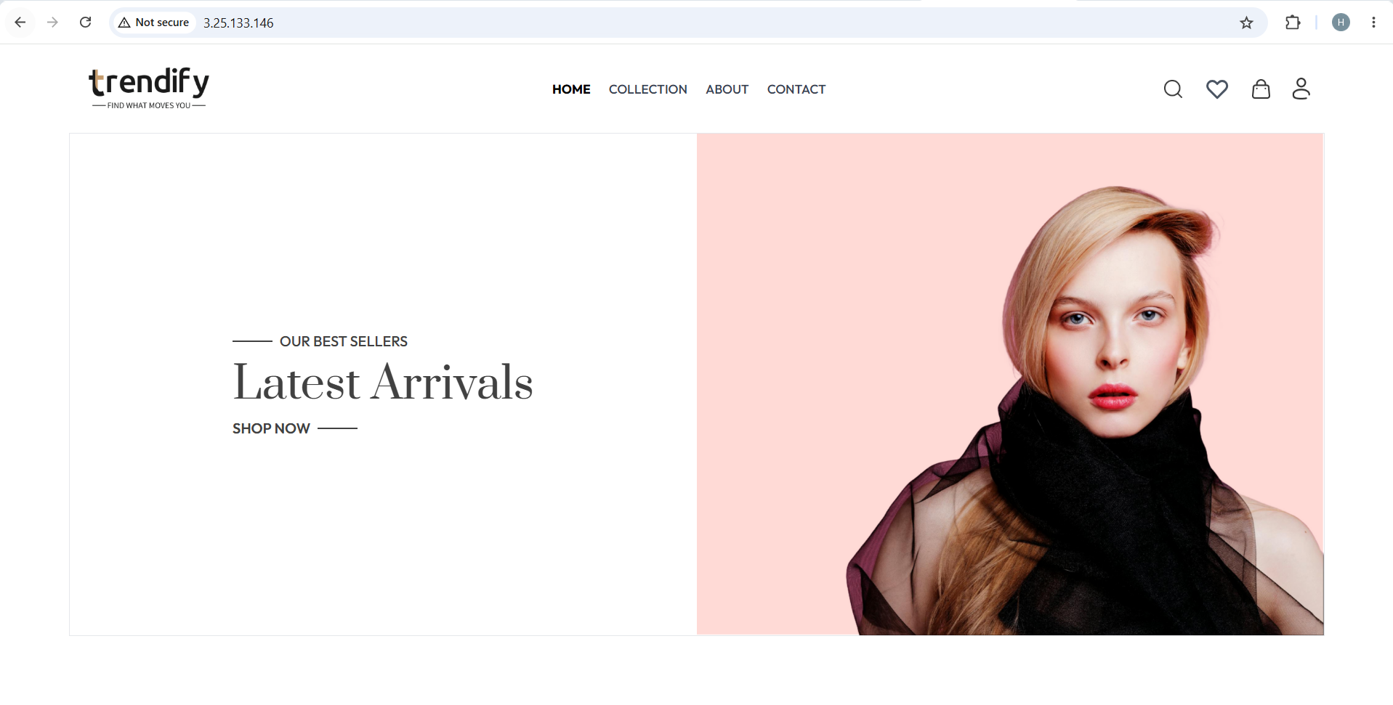
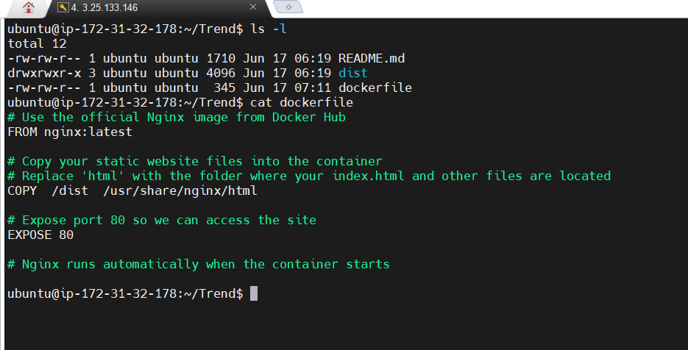
Terraform:
- Define infrastructure in main.tf to create VPC, IAM, EC2 with Jenkins, etc.
- Use terraform command to provision infrastructure.

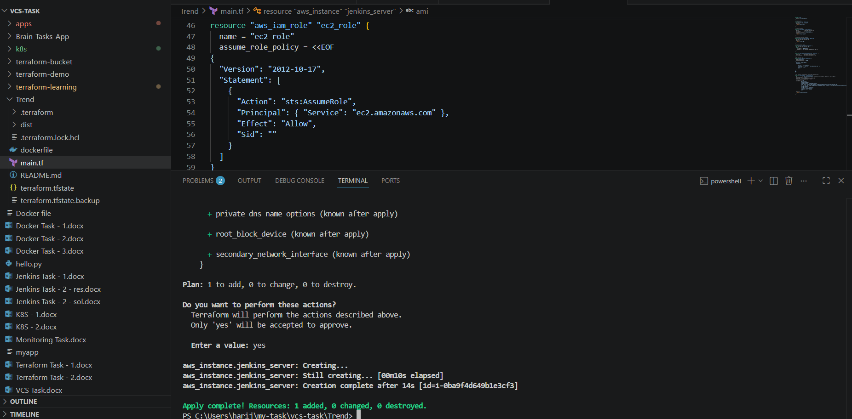
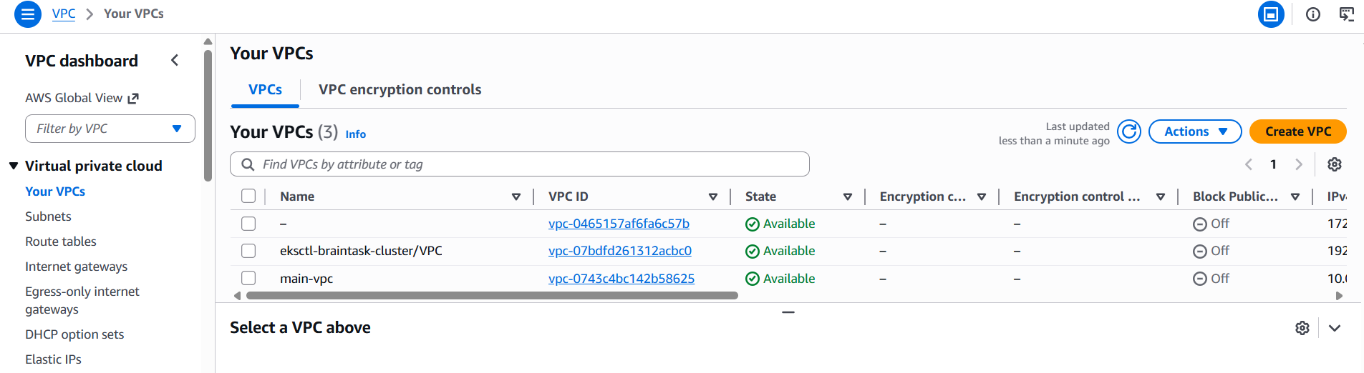
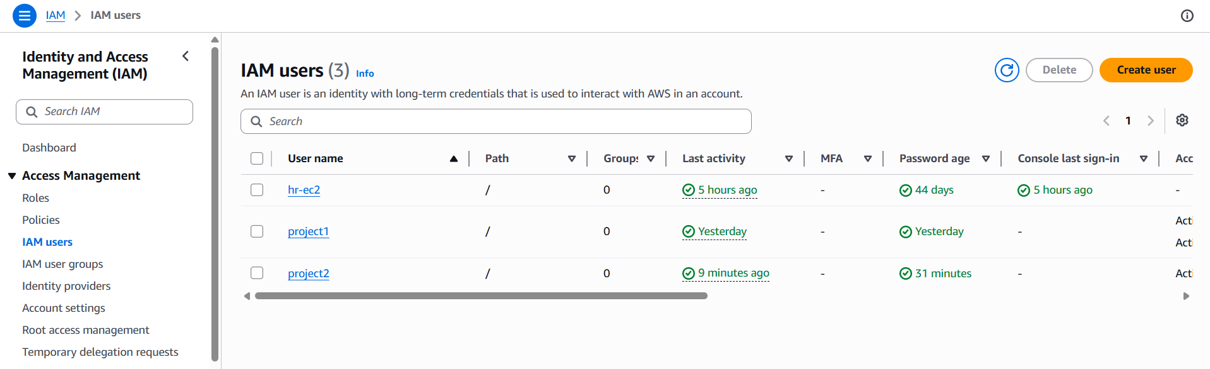

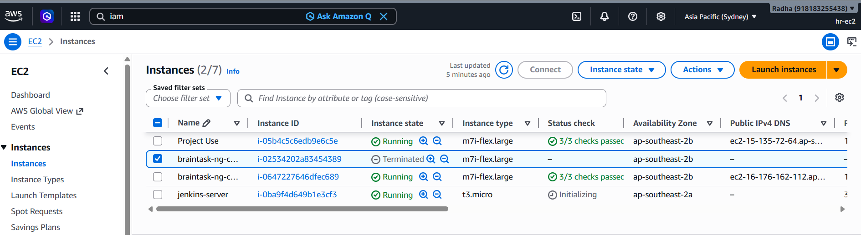
DockerHub:
- Create a DockerHub repository.

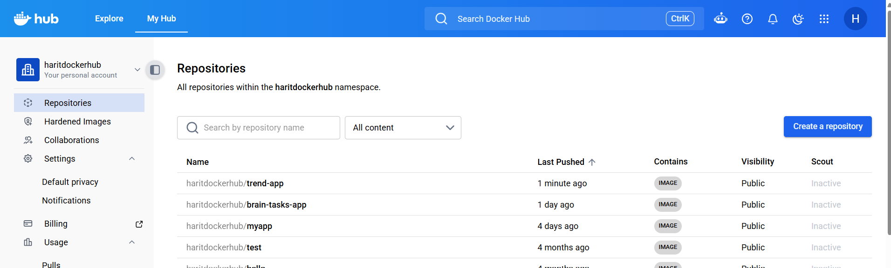

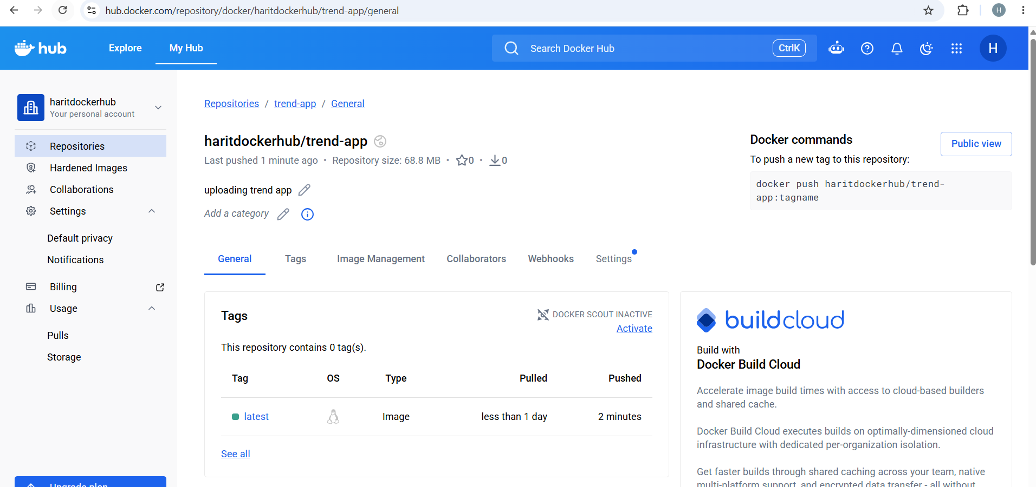

Kubernetes:
- Setup Kubernetes in AWS EKS and Confirm EKS cluster is running.
- Write deployment and service YAML files.
- Deploy using kubectl via Jenkins.
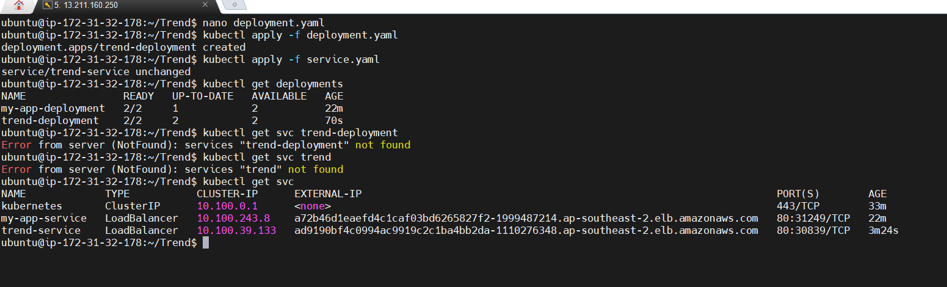
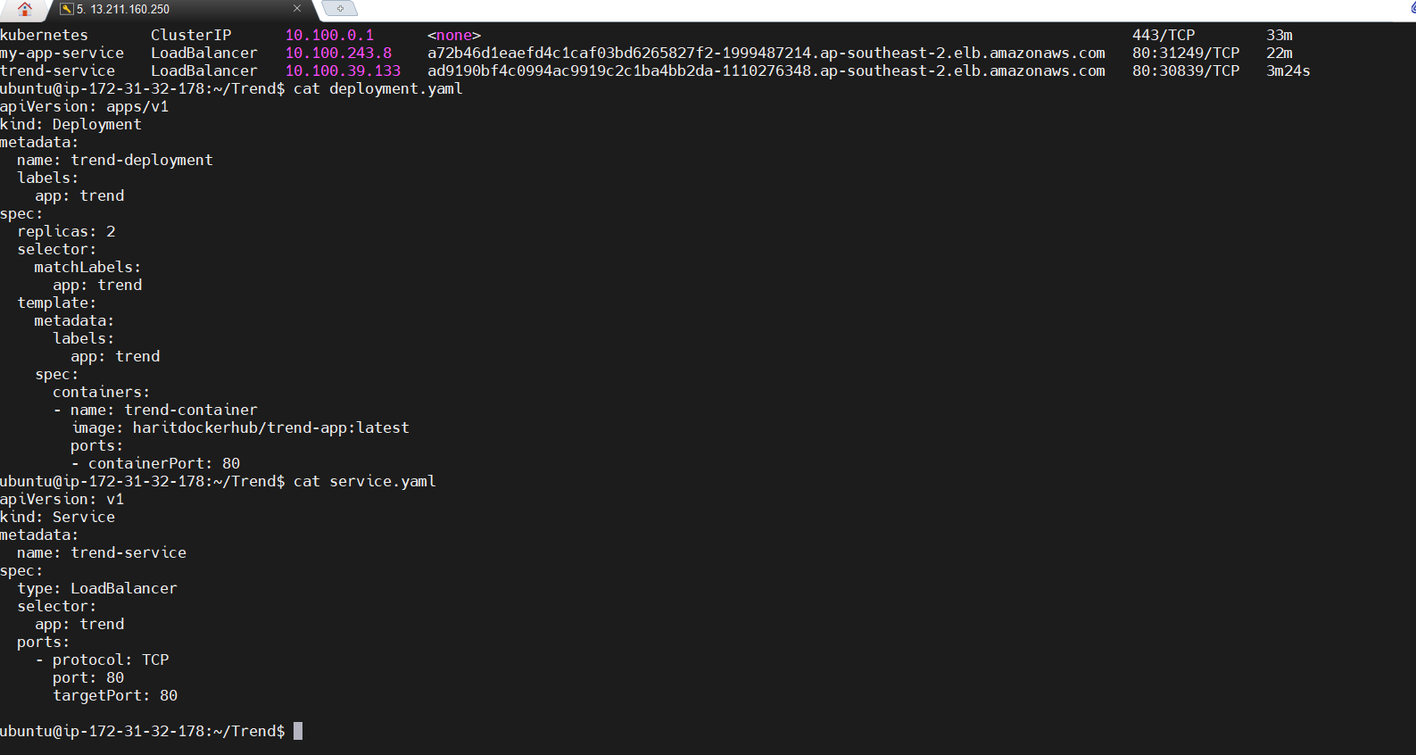
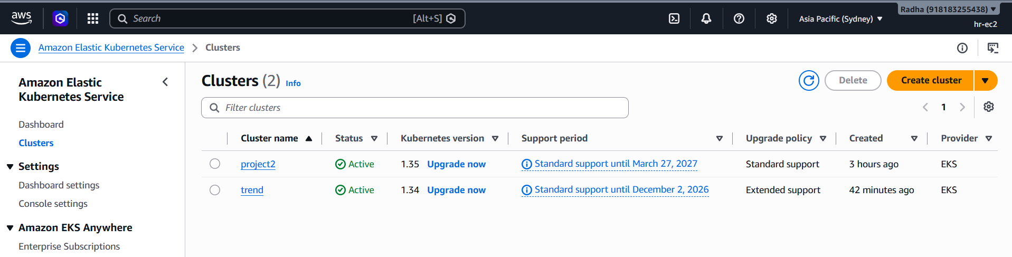

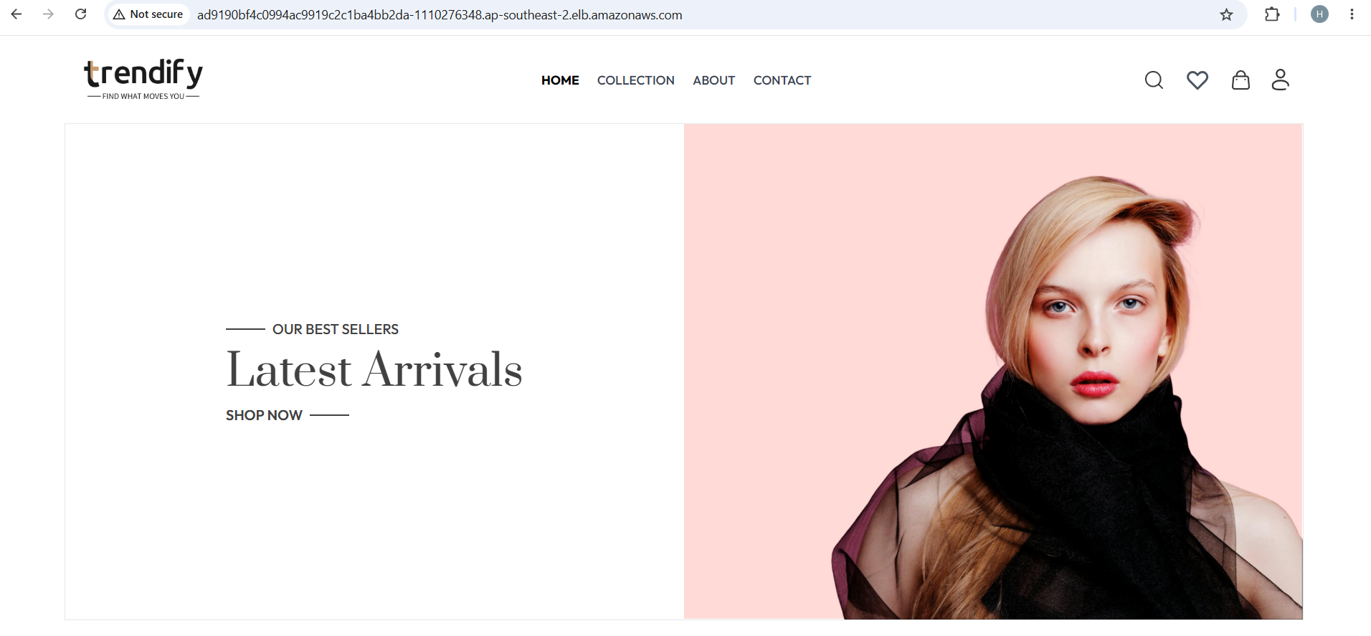

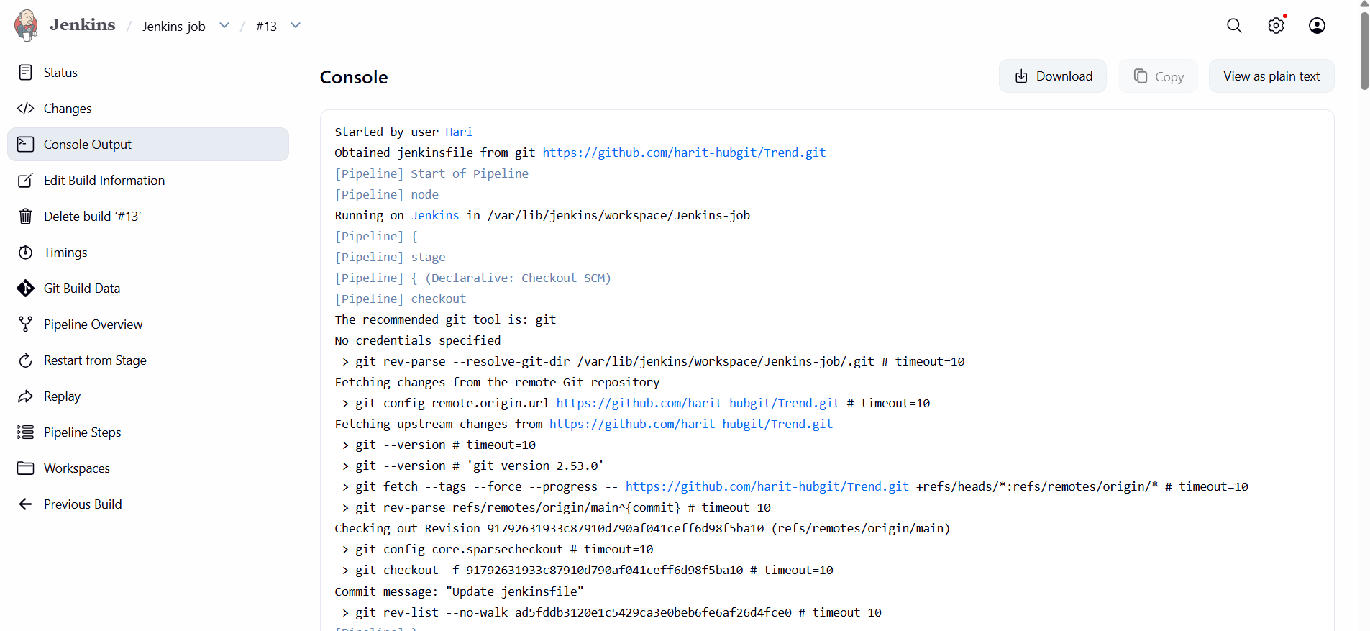
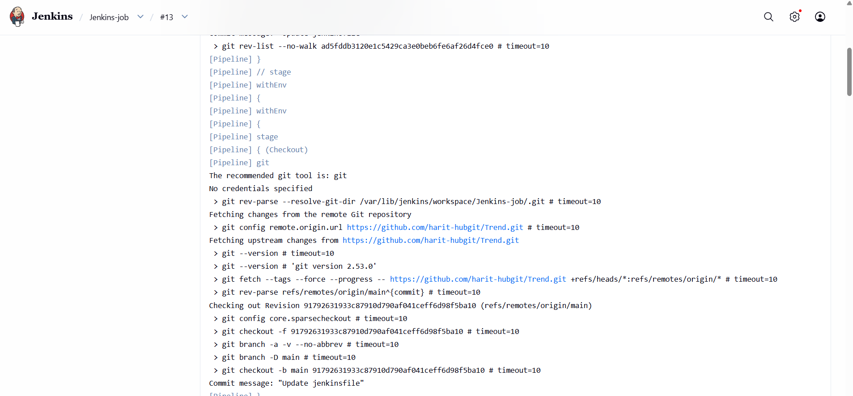
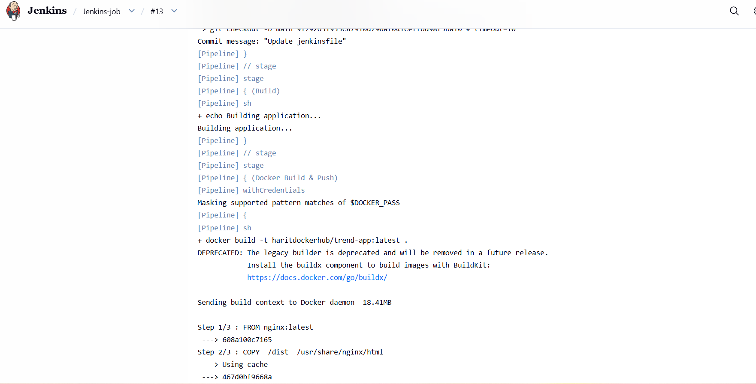
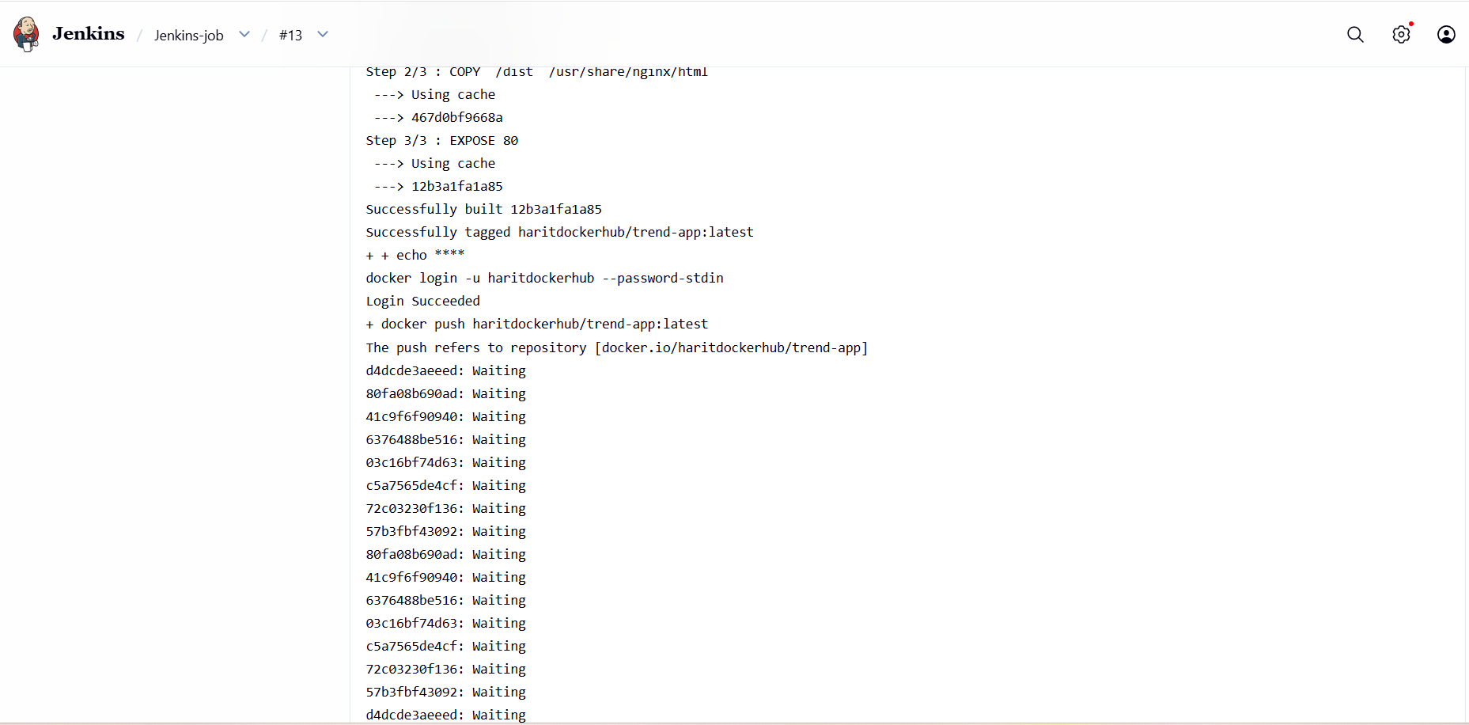
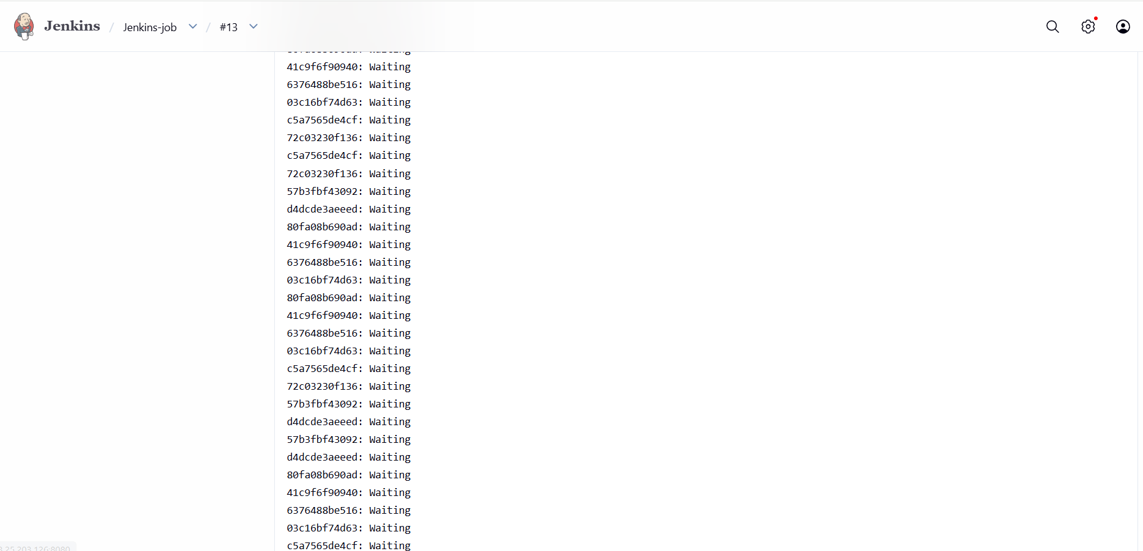
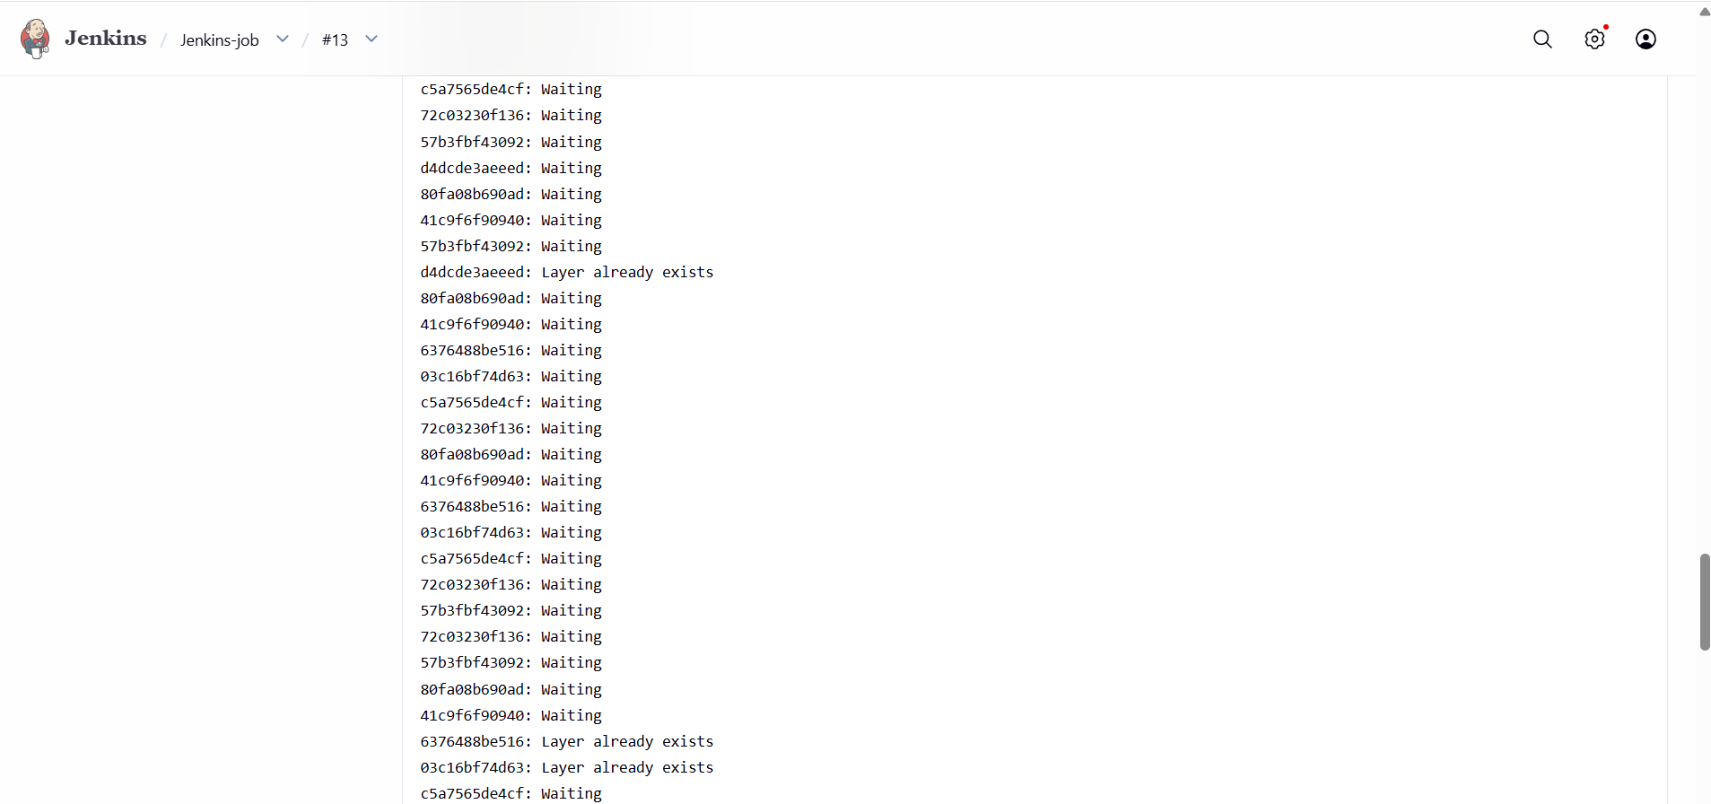
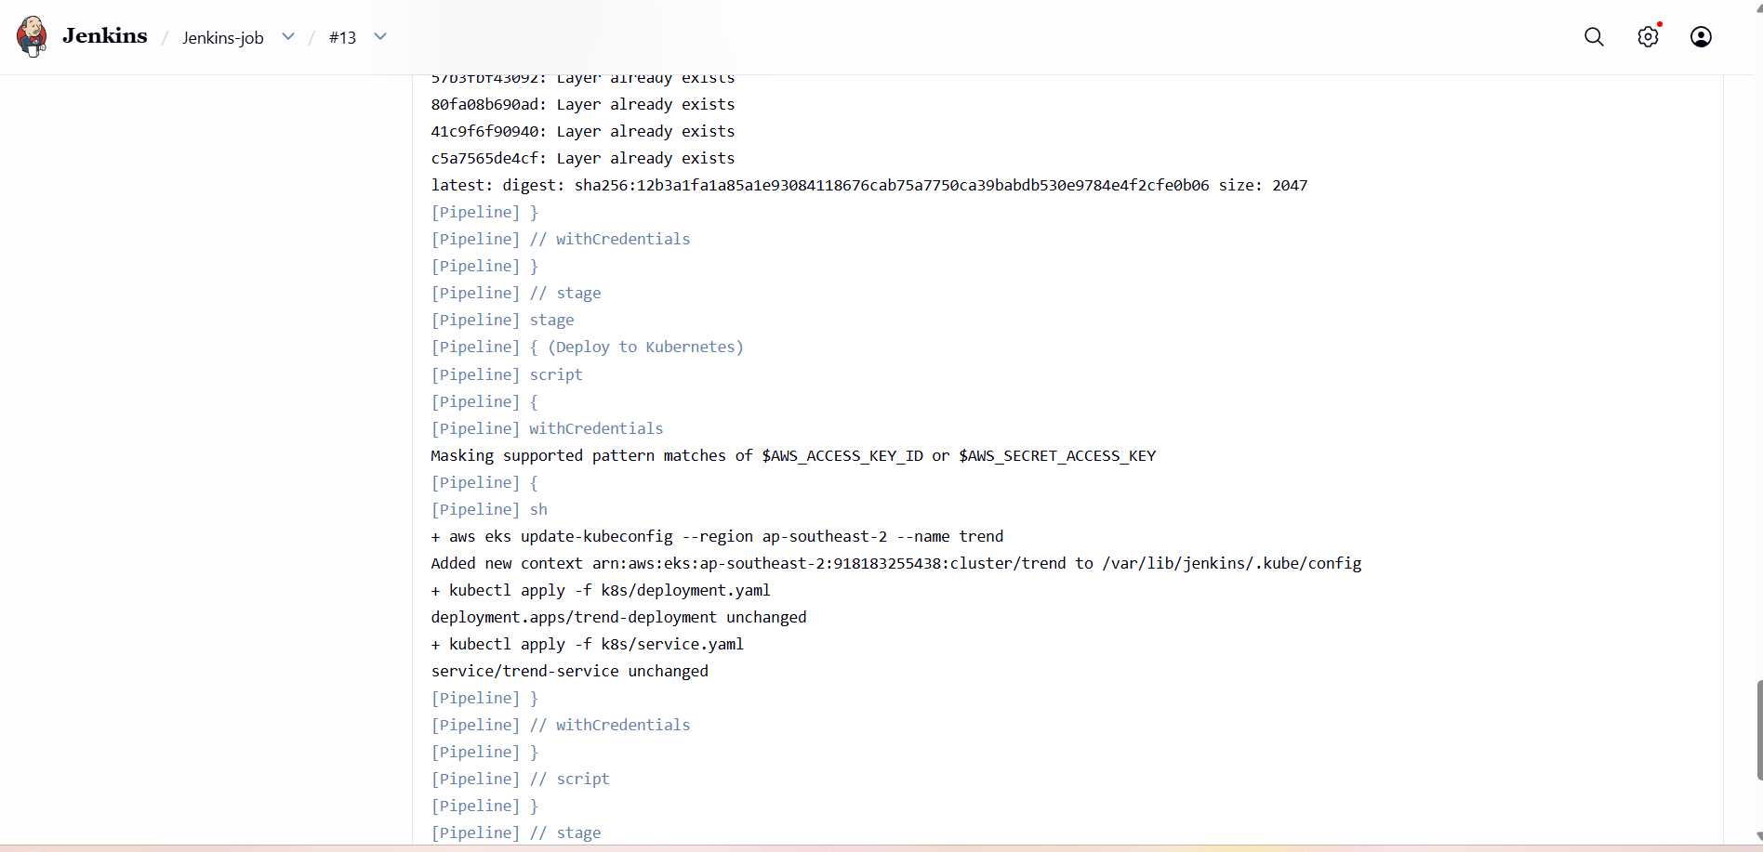
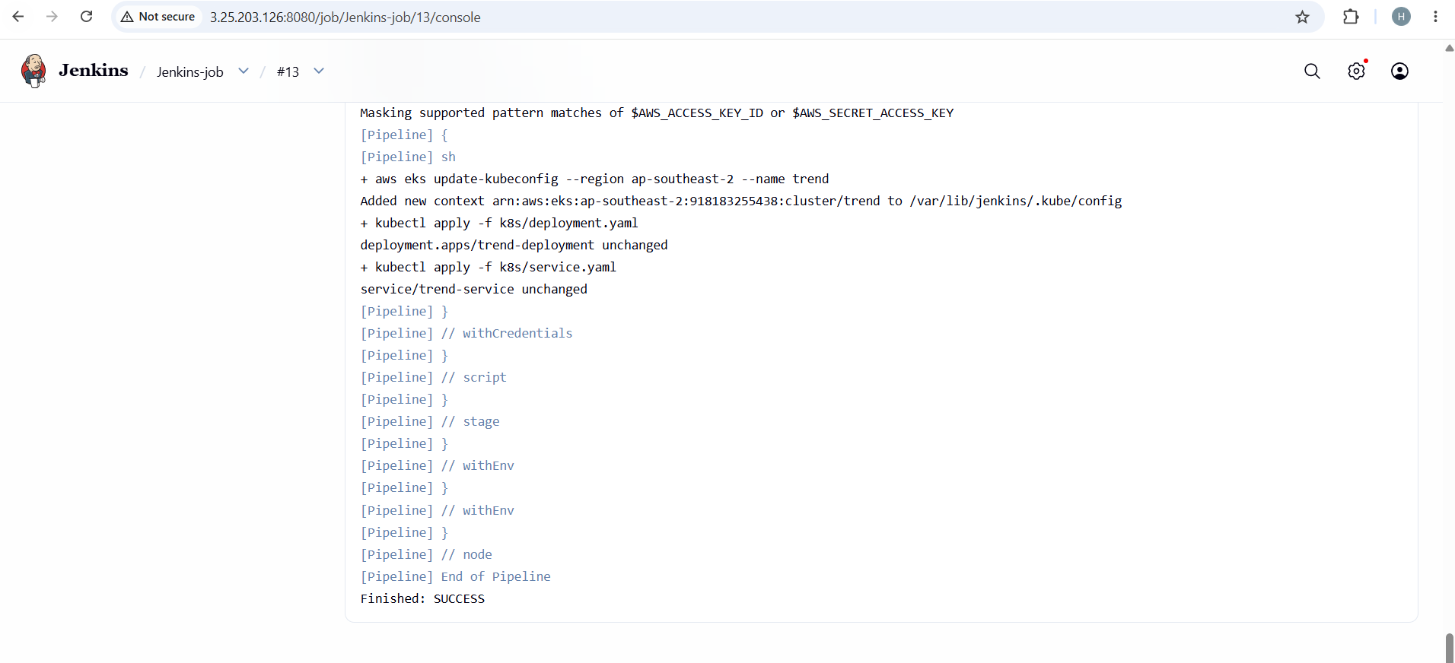
Monitoring:
- Setup a monitoring system to check the health of the cluster or application (opensource) is highly appreciable.
